THE ISLAMIA UNIVERSITY OF BAHAWALPUR
Version: 1.0

Department of Information Technology

SOFTWARE DESIGN DOCUMENT
(SDD)

E-COMMERCE WEBSITE WITH CHAT-BOT

Prepared By | M. Saqlain
Roll Number | S23BINFT1M01148
Session | Spring/Fall 2023–2027
Supervisor | Mr Suleman Javed
Document Version | 1.0
Date | 10 June 2026

Table of Contents

1. INTRODUCTION 4
1.1 Purpose 4
1.2 Scope 4
1.3 Overview 5
1.4 Reference Material 5
1.5 Definitions and Acronyms 6
2. SYSTEM OVERVIEW 7
3. SYSTEM ARCHITECTURE 8
3.2 Decomposition Description 9
3.3 Design Rationale 14
4. DATA DESIGN 16
4.1 Data Description 16
4.2 Data Dictionary 18
5. COMPONENT DESIGN 21
5.1 User Registration Algorithm 21
5.2 User Login Algorithm 21
5.3 Add to Cart Algorithm 21
5.4 Place Order Algorithm 21
5.5 Chatbot FAQ Matching Algorithm 22
5.6 Admin Product Management Algorithm 22
6. HUMAN INTERFACE DESIGN 23
6.1 Overview of User Interface 23
6.2 Screen Images 24
6.3 Screen Objects and Actions 27
7. REQUIREMENTS MATRIX 29
8. APPENDICES 31

INTRODUCTION
The E-Commerce Website with FAQs Chatbot Integration is a web-based application that enables online shopping with features such as user registration, product browsing, cart management, and order placement. It provides a simple and user-friendly interface to enhance the overall shopping experience. The system also includes an integrated FAQ chatbot that offers instant responses to common customer queries using predefined data stored in MongoDB, reducing the need for manual customer support. This improves user engagement and ensures quick problem resolution.
Additionally, the platform supports role-based access, allowing administrators to manage products, orders, and FAQs efficiently, while customers can interact with the system. The application is developed using React.js, Node.js, Express.js, and MongoDB, with JWT authentication for secure access. It follows a 3-tier client-server architecture and applies Agile methodology along with Object-Oriented Programming principles for scalable, maintainable, and efficient system development.

1.1 Purpose
The purpose of this system is to provide a secure and efficient online shopping platform integrated with an FAQ chatbot for automated customer assistance. The system helps customers purchase products easily while enabling administrators to manage products and orders effectively.
The chatbot improves user experience by providing quick responses to frequently asked questions, reducing the need for manual customer support and enhancing overall system usability. Additionally, the system aims to streamline the complete e-commerce workflow, including product management, cart operations, and order processing in a centralized platform. It ensures secure user authentication and data handling through JWT-based access control.
The project also focuses on improving scalability and maintainability by using a 3-tier architecture and modern web technologies. Overall, it enhances customer satisfaction, reduces operational workload, and provides a reliable and responsive online shopping environment.

1.2 Scope
The E-Commerce Website with FAQs Chatbot Integration is a web-based software system developed to facilitate online shopping for general customers, combined with an automated customer support mechanism. The system is built using a modern JavaScript-based technology stack comprising React.js for the frontend, Node.js and Express.js for the backend, and MongoDB as the primary database.
The scope of this system encompasses the following major functional areas:
- User registration, login, and JWT-based authentication with role-based access control for customers and administrators.
- Product browsing, product detail viewing, shopping cart management, and order placement by customers.
- Administrative product management including creation, modification, and deletion of product listings and order management.
- An integrated FAQs chatbot that accepts user queries and returns relevant automated responses fetched from a MongoDB database.
The goal of this project is to demonstrate a practical, full-stack e-commerce solution with basic automated customer service capabilities, enhancing the overall user experience.

1.3 Overview
This Software Design Description document is organized according to the standard SDD template prescribed by the Department of Computer Science, The Islamia University of Bahawalpur. The document is structured as follows:
- Section 1 (Introduction) provides the purpose, scope, and an overview of this document along with reference materials and definitions.
- Section 2 (System Overview) offers a general description of the system, its context, and the design environment.
- Section 3 (System Architecture) presents the architectural design, decomposition description with UML and DFD diagrams, and the rationale behind design decisions.
- Section 4 (Data Design) describes the data structures and the data dictionary.
- Section 5 (Component Design) provides pseudocode and algorithmic descriptions for the major system components.
- Section 6 (Human Interface Design) describes the user interface design, screen images, and screen objects.
- Section 7 (Requirements Matrix) provides a traceability matrix linking functional requirements to system components.
- Section 8 (Appendices) contains supplementary material.

1.4 Reference Material
The following documents and resources were referenced during the preparation of this Software Design Description:
- Software Requirements Specification (SRS) – E-Commerce Website with FAQs Chatbot Integration, Version 1.0, Muhammad Waqas, 2026.
- IEEE Std 1016-2009: IEEE Standard for Information Technology – Systems Design – Software Design Descriptions.
- React.js Official Documentation – https://react.dev
- Node.js Official Documentation – https://nodejs.org
- Express.js Official Documentation – https://expressjs.com
- MongoDB Official Documentation – https://www.mongodb.com/docs
- JSON Web Token (JWT) Documentation – https://jwt.io
- Agile Software Development Methodology – Beck et al., 2001 Agile Manifesto.

1.5 Definitions and Acronyms
Term / Acronym | Definition
SDD | Software Design Description – a document that describes the design of a software system.
SRS | Software Requirements Specification – a document defining system functional and non-functional requirements.
API | Application Programming Interface – a set of protocols for building and integrating software applications.
JWT | JSON Web Token – a compact, URL-safe token format used for secure user authentication.
MongoDB | A NoSQL document-oriented database system that stores data as JSON-like BSON documents.
React.js | A JavaScript library for building component-based user interfaces, maintained by Meta.
Node.js | A server-side JavaScript runtime environment built on Chrome's V8 engine.
Express.js | A minimal and flexible Node.js web application framework providing routing and middleware features.
FAQ | Frequently Asked Question – a predefined question-answer pair stored in the database for chatbot use.
DFD | Data Flow Diagram – a graphical representation of how data moves through a system.
ER Diagram | Entity-Relationship Diagram – a visual representation of database entities and their relationships.
OOP | Object-Oriented Programming – a programming paradigm based on objects containing data and methods.
UI | User Interface – the space where interactions between users and the system occur.
REST | Representational State Transfer – an architectural style for designing networked applications via HTTP.
CRUD | Create, Read, Update, Delete – the four basic operations of persistent storage.

2. SYSTEM OVERVIEW
The E-Commerce Website with FAQs Chatbot Integration is a full-stack web application that provides an online shopping platform with product browsing, cart management, order placement, and automated customer support via a chatbot. It follows a 3-tier architecture: the frontend is built with React.js, the backend uses Node.js and Express.js, and MongoDB is used for storing users, products, orders, cart data, FAQs, and chat records.
The system supports two user roles: Customers, who can register, browse products, manage carts, place orders, and use the chatbot; and Administrators, who manage products, orders, FAQs, and system data.
Security is ensured through JWT-based authentication and role-based access control. The chatbot provides automated responses by matching user queries with stored FAQs using keyword search in MongoDB, without external AI services.
The project is developed using the Agile model with iterative improvements and follows Object-Oriented Programming principles for modularity, reusability, and maintainability.
Key Features:
- Full-stack e-commerce platform with integrated FAQ chatbot for customer support
- Secure role-based system with JWT authentication for users and administrators

3. SYSTEM ARCHITECTURE
3.1 Architectural Design
The E-Commerce Website with FAQs Chatbot Integration uses a 3-Tier Client-Server Architecture, separating the system into Presentation, Application, and Data layers for better scalability and modularity.
Presentation Layer (React.js):
Handles the user interface as a Single Page Application (SPA) and communicates with the backend via RESTful APIs using Axios.
Application Layer (Node.js + Express.js):
Implements business logic including authentication, product management, cart, orders, and chatbot processing. JWT is used for secure API access.
Data Layer (MongoDB):
Stores all application data in BSON format. Mongoose is used for schema definition and database interaction.
Key Points:
- Ensures separation of concerns and easy maintenance
- Enables efficient communication through RESTful APIs
Figure 3.1 shows the system architecture and layer interactions.

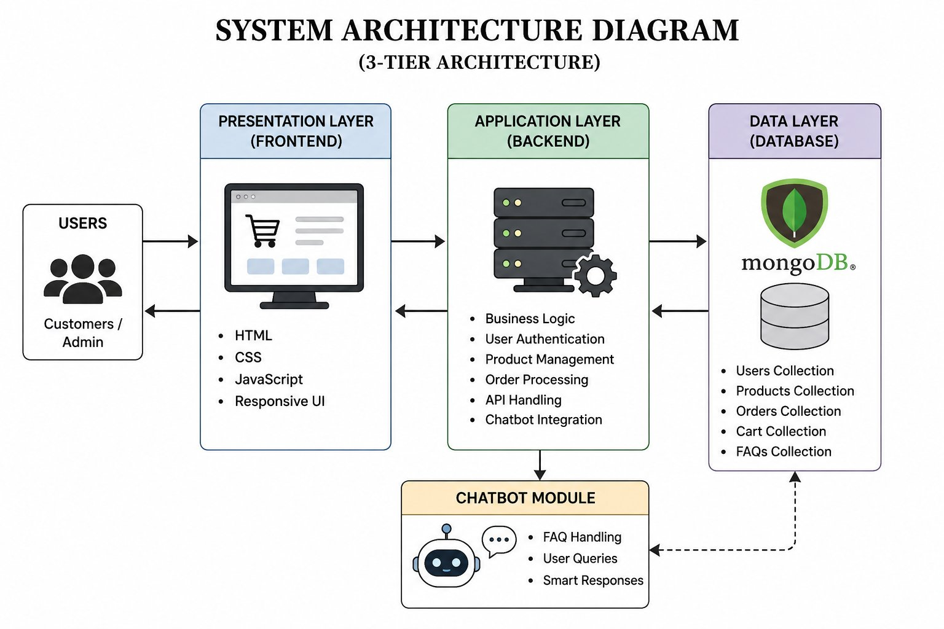
Figure 3.1: System Architecture Diagram

3.2 Decomposition Description
The system is decomposed into six primary subsystems, each responsible for a distinct set of functionalities. The decomposition follows Object-Oriented Programming principles, with each subsystem modelled as a set of interacting components.
3.2.1 User Management Module
Responsible for user registration, login, JWT token generation, token validation, and role-based access enforcement. Key components include the AUTH Controller, User Model, and AUTH Middleware.
3.2.2 Product Module
Handles product listing retrieval and individual product detail display. The Product Controller interacts with the Product Model to serve product data to the frontend.
3.2.3 Cart Module
Manages user-specific shopping cart operations including item addition, quantity update, and item removal. The Cart Controller operates on the Cart and Cart Items collections.
3.2.4 Order Module
Processes order placement from cart data, stores order records in MongoDB, and allows users to view their order history. The Order Controller coordinates between the Cart, Orders, and Order Items collections.
3.2.5 Admin Module
Provides administrators with capabilities to perform CRUD operations on products and manage order statuses. Access is restricted through JWT role validation middleware.
3.2.6 Chatbot Module
Accepts user text queries, performs keyword-based matching against the FAQs MongoDB collection, and returns the most relevant predefined answer. If no match is found, a default fallback response is returned.

DFD Level 0 – Context Diagram
Figure 3.2 presents the DFD Level 0 (Context Diagram) showing the system as a single process with its external entities and major data flows.
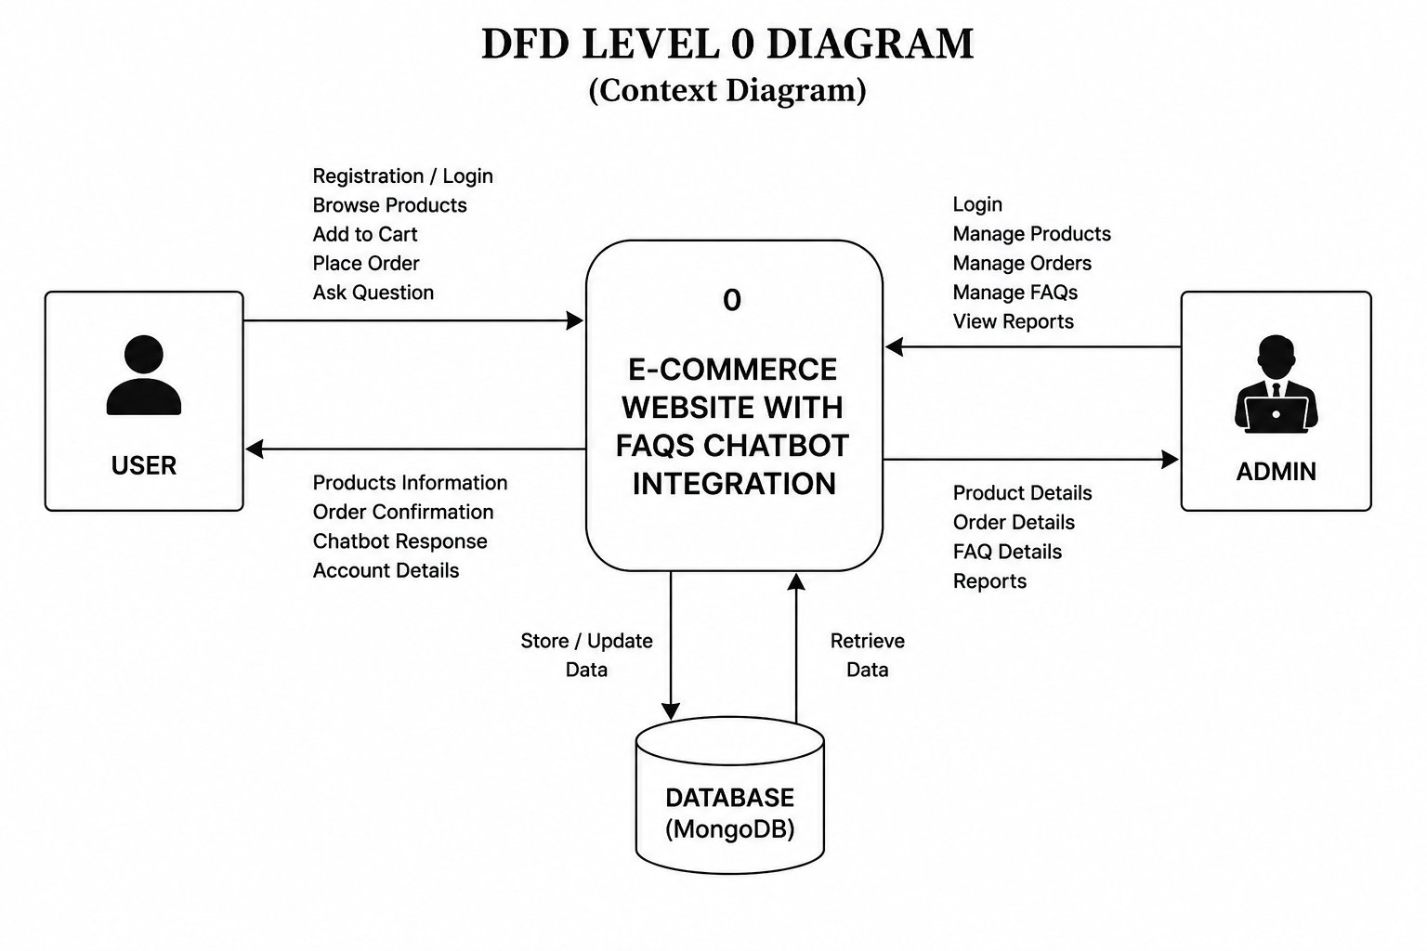
Figure 3.2: DFD Level 0

DFD Level 1 – Detailed Process Diagram
Figure 3.3 presents the DFD Level 1 diagram decomposing the system into individual process modules with their data flows.
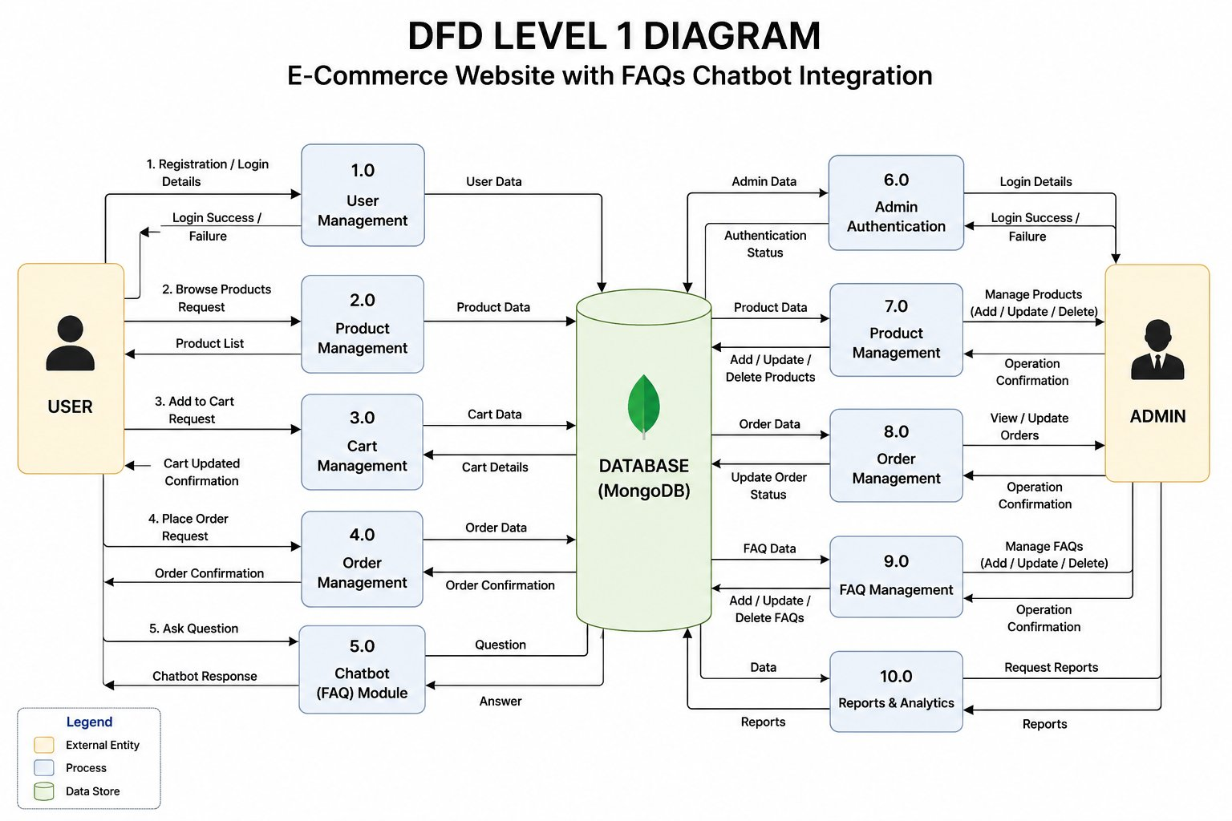
Figure 3.3: DFD Level 1
.

Sequence Diagrams
Figure 3.4 presents the Sequence Diagram for the Order Placement process.
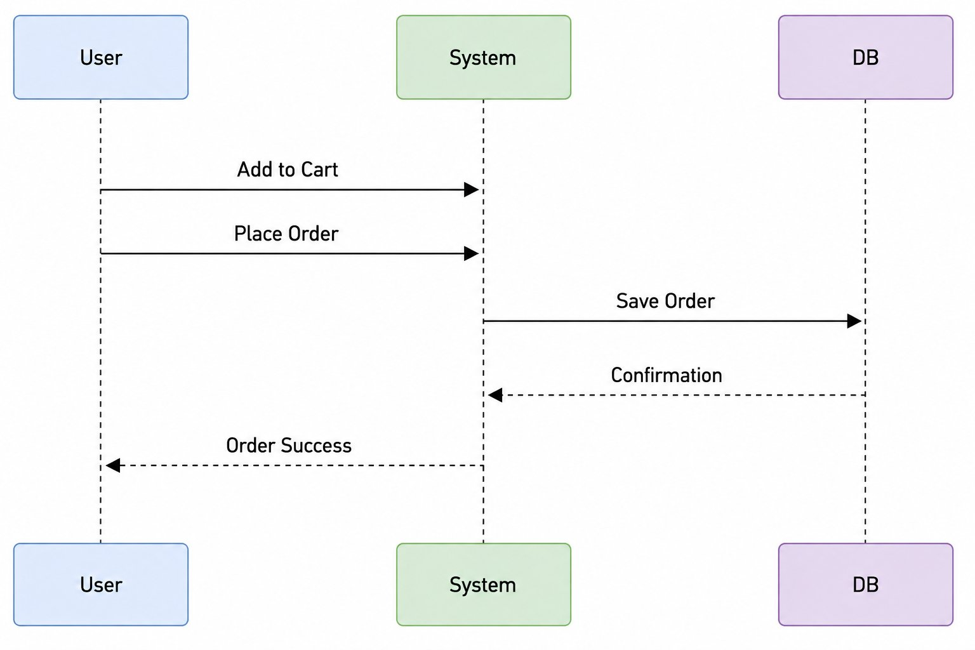
Figure 3.4: Sequence Diagram

Figure 3.5 presents the Sequence Diagram for the Chatbot FAQ interaction.

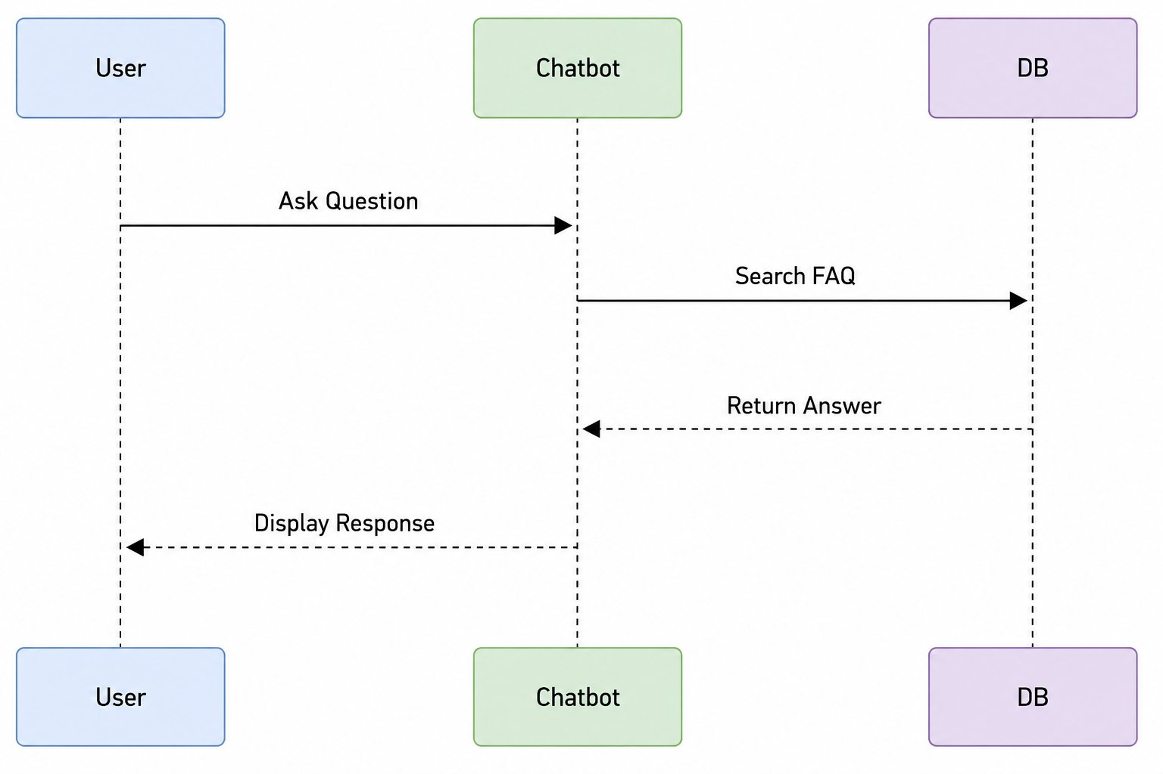
Figure 3.5: Sequence Diagram

UI Flow Diagram
Figure 3.6 presents the UI Flow Diagram of the system.
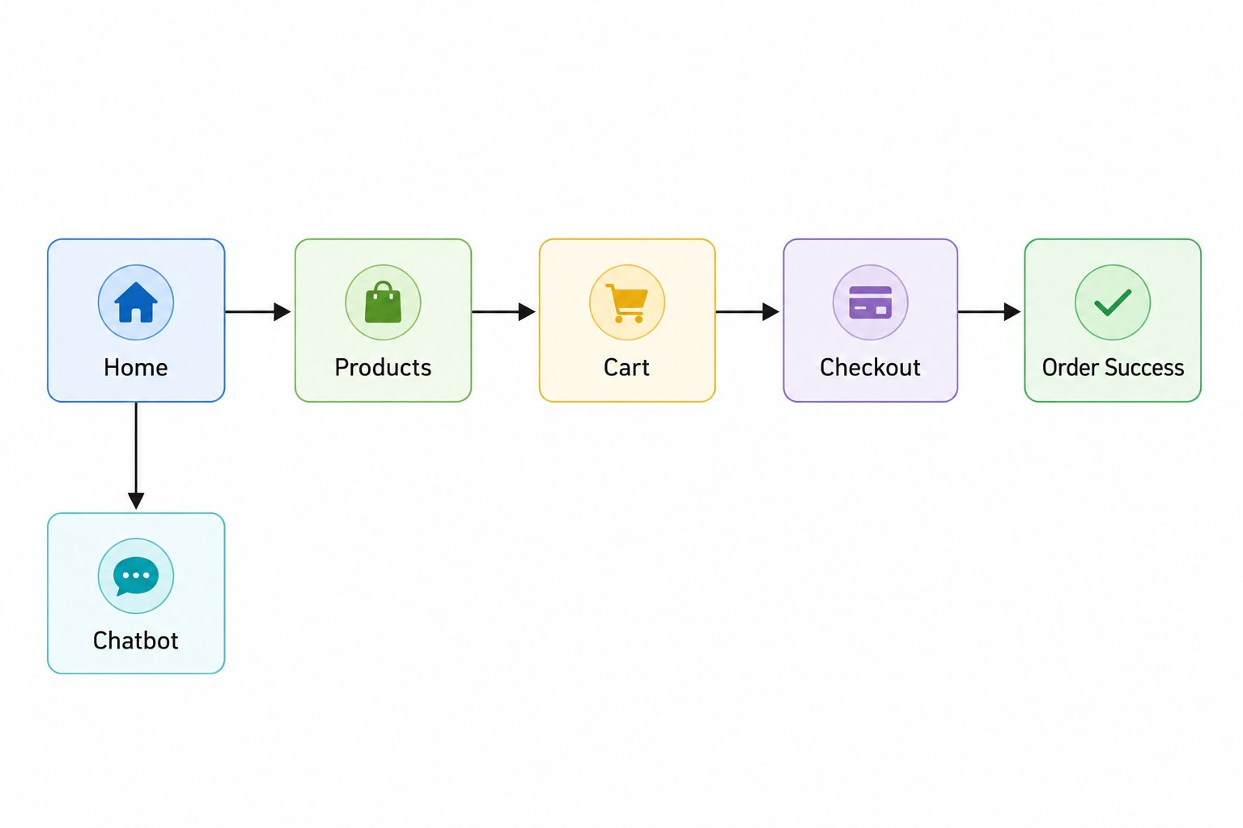
Figure 3.6: UI Flow Diagram

3.3 Design Rationale
The 3-Tier Client-Server Architecture was selected over alternative patterns such as a monolithic architecture or a microservices architecture for the following reasons:
- Separation of Concerns: Decoupling the frontend, backend, and database layers allows each tier to be developed, tested, and modified independently without affecting the others.
- Scalability: The stateless REST API architecture allows the backend to scale horizontally by adding more server instances behind a load balancer if required in future deployments.
- Technology Appropriateness: React.js provides a reactive, component-based UI that is well-suited for dynamic e-commerce interfaces. Node.js with Express.js offers a lightweight, non-blocking I/O model suitable for handling concurrent API requests. MongoDB's flexible document model accommodates the semi-structured nature of e-commerce data such as product attributes and order line items.
- JWT Authentication: Stateless token-based authentication eliminates the need for server-side session storage, simplifying horizontal scaling and reducing server memory overhead.
A micro services architecture was considered but rejected due to the scope of a Final Year Project, as it would introduce excessive operational complexity including service discovery, inter-service communication, and distributed tracing. A monolithic architecture was also considered but dismissed because it would tightly couple all concerns, making future modifications more difficult.

4. DATA DESIGN

4.1 Data Description
The system's information domain is transformed into a set of MongoDB collections (documents). MongoDB's document-oriented model was chosen because it naturally maps to the JSON data structures used throughout the React.js frontend and Node.js backend, minimizing the need for data transformation layers.
All collections are managed through Mongoose schemas defined in the backend. Each document uses MongoDB's Objected as its primary identifier. Relationships between collections are represented using Objected references (similar to foreign keys in relational databases), which are resolved at query time using Mongoose's populate () method.
The following collections form the data backbone of the system:
- Users: Stores customer and administrator account information including credentials and role.
- Products: Contains product catalogue data including name, description, price, category, image URL, and stock count.
- Cart: Represents a user's active shopping cart with a reference to the owning user.
- Cart Items: Stores individual line items within a cart, referencing both the Cart and Product documents.
- Orders: Records placed orders with shipping information, total amount, status, and a reference to the user.
- Order Items: Stores the individual product lines within a placed order.
- FAQs: Contains predefined question-answer pairs organized by category, queried by the chatbot module.
- Chat Sessions: Records chatbot conversation sessions linked to a user.
- Chat Messages: Stores individual messages exchanged within a chat session.

Figure 4.1 below presents the ER Diagram showing all entities, their attributes, and the relationships between them.
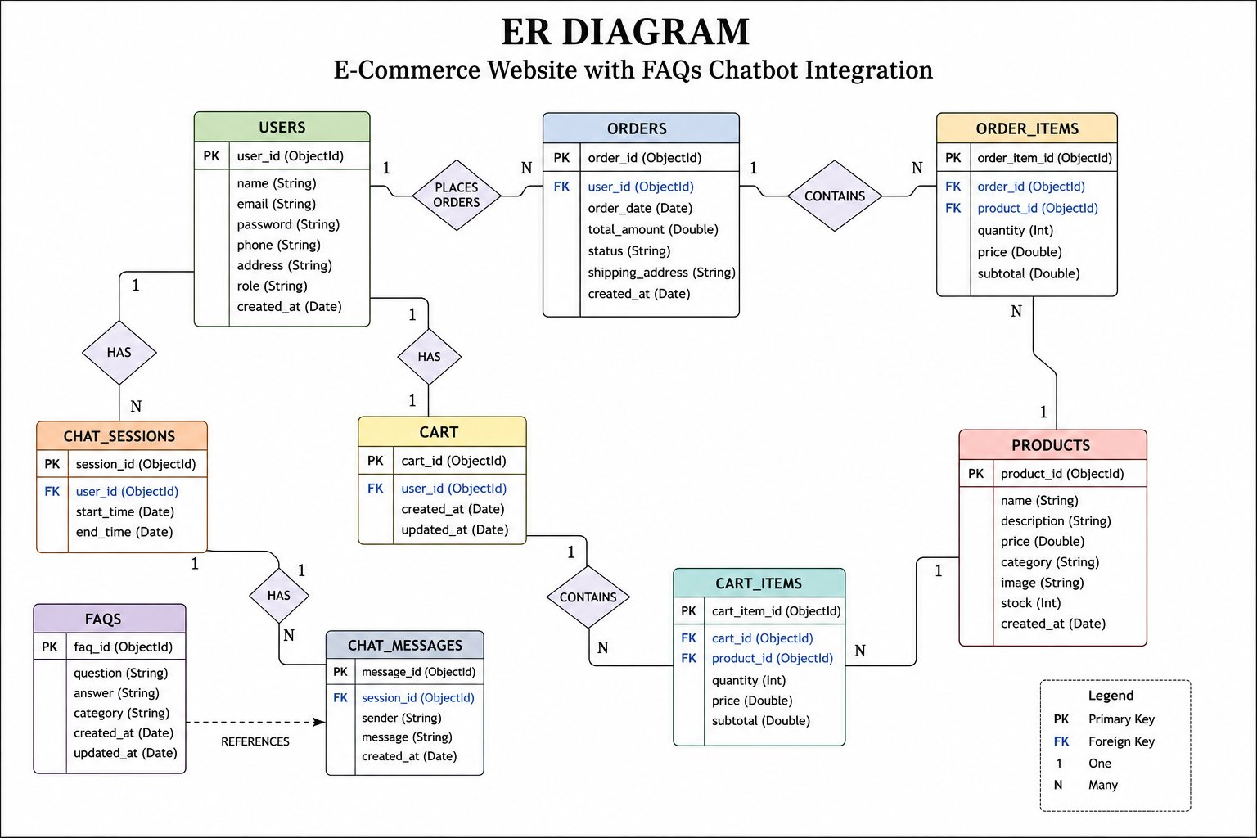
Figure 4.1: ER Diagram

4.2 Data Dictionary
The following data dictionary provides detailed definitions of all major entities and their attributes used within the system.

Table 4.1: Users Collection
Field | Type | Constraints | Description
user_id | ObjectId | PK, Not Null | Unique identifier auto-generated by MongoDB.
name | String | Required | Full name of the user.
email | String | Required, Unique | User email address used for login.
password | String | Required | Bcrypt-hashed user password.
phone | String | Optional | User contact phone number.
address | String | Optional | Default shipping address.
role | String | Default: 'user' | Defines access level: 'user' or 'admin'.
created_at | Date | Auto-generated | Timestamp of account creation.

Table 4.2: Products Collection
Field | Type | Constraints | Description
product_id | ObjectId | PK, Not Null | Unique identifier for the product.
name | String | Required | Product name/title.
description | String | Required | Detailed product description.
price | Double | Required, >= 0 | Product price in PKR.
category | String | Required | Product category (e.g., Electronics, Clothing).
image | String | Optional | URL path to the product image.
stock | Int | Required, >= 0 | Number of available units in inventory.
created_at | Date | Auto-generated | Timestamp when product was added.

Table 4.3: Orders Collection
Field | Type | Constraints | Description
order_id | ObjectId | PK, Not Null | Unique identifier for each order.
user_id | ObjectId | FK -> Users | Reference to the user who placed the order.
order_date | Date | Auto-generated | Date and time the order was placed.
total_amount | Double | Required | Total cost of the order in PKR.
status | String | Default: 'Pending' | Order status: Pending, Processing, Shipped, Delivered, Cancelled.
shipping_address | String | Required | Delivery address for the order.
created_at | Date | Auto-generated | Record creation timestamp.

Table 4.4: Cart Collection
Field | Type | Constraints | Description
cart_id | ObjectId | PK, Not Null | Unique identifier for the cart.
user_id | ObjectId | FK -> Users, Unique | Reference to the cart owner.
created_at | Date | Auto-generated | Cart creation timestamp.
updated_at | Date | Auto-updated | Last modification timestamp.

Table 4.5: FAQs Collection
Field | Type | Constraints | Description
faq_id | ObjectId | PK, Not Null | Unique identifier for the FAQ record.
question | String | Required | The predefined frequently asked question text.
answer | String | Required | The predefined answer to the question.
category | String | Optional | Category of the FAQ (e.g., Shipping, Returns, Payment).
created_at | Date | Auto-generated | Record creation timestamp.
updated_at | Date | Auto-updated | Record last update timestamp.

5. COMPONENT DESIGN
This section presents the algorithmic descriptions and pseudocode for each major system component. The descriptions follow a procedural style, providing sufficient detail to guide implementation without specifying language-specific syntax.

5.1 User Registration Algorithm
{ FUNCTION registerUser(name, email, password, phone, address): IF email already exists in Users collection THEN RETURN error "Email already registered" END IF hashedPassword = bcrypt.hash(password, saltRounds=10) newUser = CREATE document with name, email, hashedPassword, phone, address, role="user" INSERT newUser INTO Users collection token = JWT.sign( user_id: newUser._id, role: newUser.role ) RETURN success=true, token, user: newUser }

5.2 User Login Algorithm
{ FUNCTION loginUser(email, password): user = FIND user IN Users WHERE email = email IF user NOT FOUND THEN RETURN error "Invalid credentials" END IF isMatch = bcrypt.compare(password, user.hashedPassword) IF isMatch = FALSE THEN RETURN error "Invalid credentials" END IF token = JWT.sign( user_id: user._id, role: user.role, expiresIn: 7days ) RETURN success=true, token, user }

5.3 Add to Cart Algorithm
{ FUNCTION addToCart(user_id, product_id, quantity): product = FIND product IN Products WHERE _id = product_id IF product NOT FOUND THEN RETURN error "Product not found" END IF IF product.stock < quantity THEN RETURN error "Insufficient stock" END IF cart = FIND cart IN Cart WHERE user_id = user_id IF cart NOT FOUND THEN CREATE new cart document with user_id END IF existingItem = FIND item IN Cart_Items WHERE cart_id AND product_id match IF existingItem FOUND THEN UPDATE Cart_Items SET quantity += quantity, subtotal = newQty * product.price ELSE INSERT new Cart_Item with cart_id, product_id, quantity, price, subtotal END IF RETURN success=true, "Item added to cart" }

5.4 Place Order Algorithm
{ FUNCTION placeOrder(user_id, shipping_address): cart = FIND cart IN Cart WHERE user_id = user_id IF cart NOT FOUND THEN RETURN error "Cart is empty" END IF cartItems = FIND ALL items IN Cart_Items WHERE cart_id = cart._id IF cartItems IS EMPTY THEN RETURN error "No items in cart" END IF total_amount = SUM of subtotal for each item in cartItems order = INSERT new Order document with user_id, total_amount, status="Pending", shipping_address FOR EACH item IN cartItems DO INSERT Order_Item with order_id, product_id, quantity, price, subtotal END FOR DELETE ALL Cart_Items WHERE cart_id = cart._id RETURN success=true, order_id: order._id }

5.5 Chatbot FAQ Matching Algorithm
{ FUNCTION processChatbotQuery(user_id, userQuery): normalizedQuery = userQuery.toLowerCase().trim() keywords = EXTRACT significant words FROM normalizedQuery matchedFAQ = SEARCH FAQs collection WHERE question contains any keyword (case-insensitive regex matching) IF matchedFAQ NOT FOUND THEN response = "Sorry, I could not find an answer. Please contact our support team." ELSE response = matchedFAQ.answer END IF session = FIND or CREATE Chat_Session WHERE user_id = user_id INSERT user message and bot response INTO Chat_Messages RETURN success=true, response }

5.6 Admin Product Management Algorithm
{ FUNCTION addProduct(admin_token, name, description, price, category, image, stock): adminUser = JWT.verify(admin_token) IF adminUser.role != "admin" THEN RETURN error "Access denied: Admins only" END IF IF name IS EMPTY OR price < 0 OR stock < 0 THEN RETURN error "Invalid product data" END IF INSERT new Product document with name, description, price, category, image, stock RETURN success=true, product FUNCTION updateProduct(admin_token, product_id, updatedFields): adminUser = JWT.verify(admin_token) IF adminUser.role != "admin" THEN RETURN error "Access denied" END IF UPDATE Products SET updatedFields WHERE _id = product_id RETURN success=true, "Product updated" FUNCTION deleteProduct(admin_token, product_id): adminUser = JWT.verify(admin_token) IF adminUser.role != "admin" THEN RETURN error "Access denied" END IF DELETE FROM Products WHERE _id = product_id RETURN success=true, "Product deleted" }

6. HUMAN INTERFACE DESIGN

6.1 Overview of User Interface
The user interface of the E-Commerce Website with FAQs Chatbot Integration is designed to be clean, responsive, and intuitive, following contemporary web design principles. The frontend is developed using React.js and employs a component-based architecture where each UI section is an independent, reusable component.
The application adopts a single-page application (SPA) model, meaning that navigation between different views does not trigger full page reloads. Instead, React Router is used to manage client-side routing, providing a smooth and fast user experience. The interface is fully responsive and adapts to various screen sizes including desktop, tablet, and mobile devices.
The UI is organized around the following primary user flows:
- Customer Flow: Home Page (Product Listing) → Product Details → Add to Cart → Cart/Checkout → Order Confirmation.
- Chatbot Flow: Home Page → Chatbot Widget → Enter Query → Receive Response.
- Admin Flow: Admin Login → Admin Dashboard → Manage Products / Manage Orders.
Color Scheme: The application uses a professional blue and white primary palette with accent colors for call-to-action buttons (green for 'Add to Cart', red for 'Delete', blue for 'View Details'). Typography uses a clean sans-serif font family for readability.
Navigation: A persistent top navigation bar is present across all pages, providing links to the Home Page, Products, Cart (with item count badge), and Login/Logout options. The Admin Dashboard is accessible through a separate login route protected by JWT role validation.
Feedback Mechanisms: The system provides real-time feedback to users through toast notifications for actions such as successful login, item added to cart, order placed, and error messages. Loading spinners are displayed during API call processing to indicate system activity.

6.2 Screen Images
The following screen images represent the four primary interfaces of the E-Commerce Website with FAQs Chatbot Integration. These screens demonstrate the core functionality accessible to end users.
Screen 1: Home Page – Product Listing
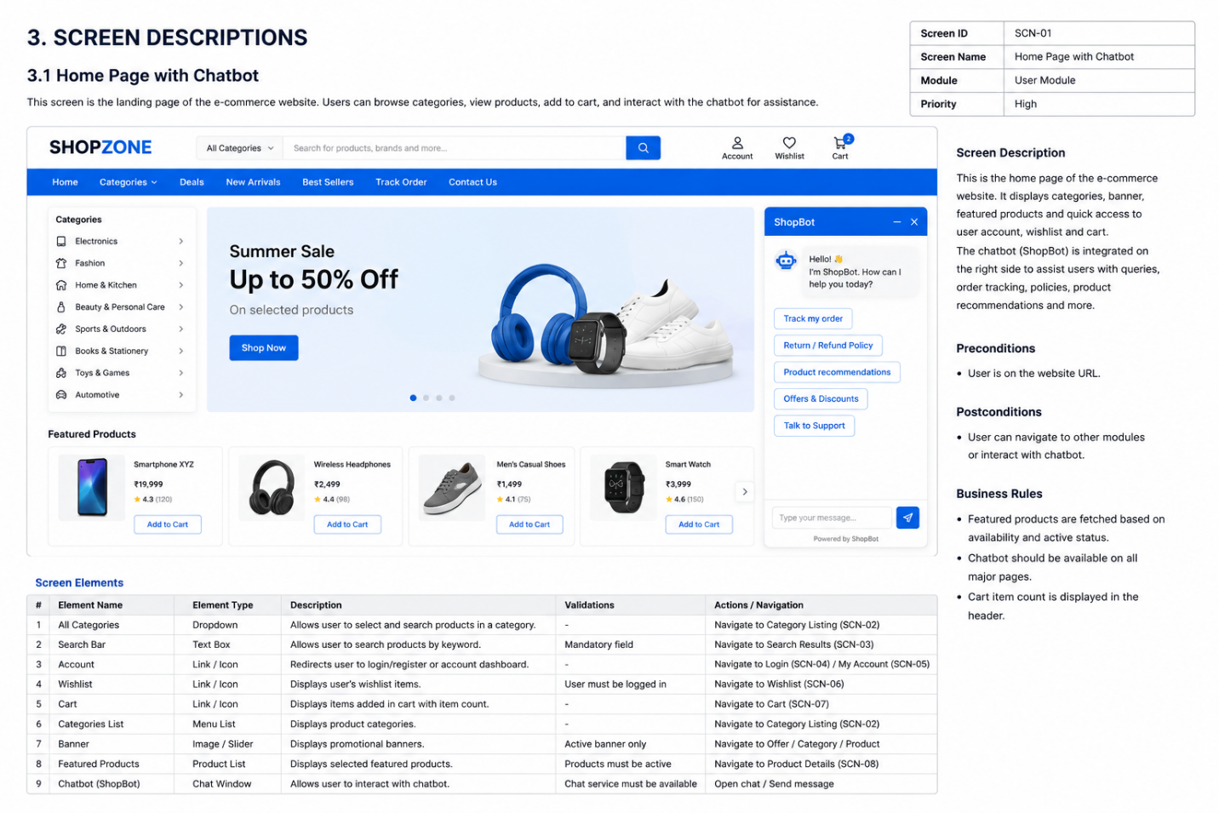

Screen 2: Product Details Page
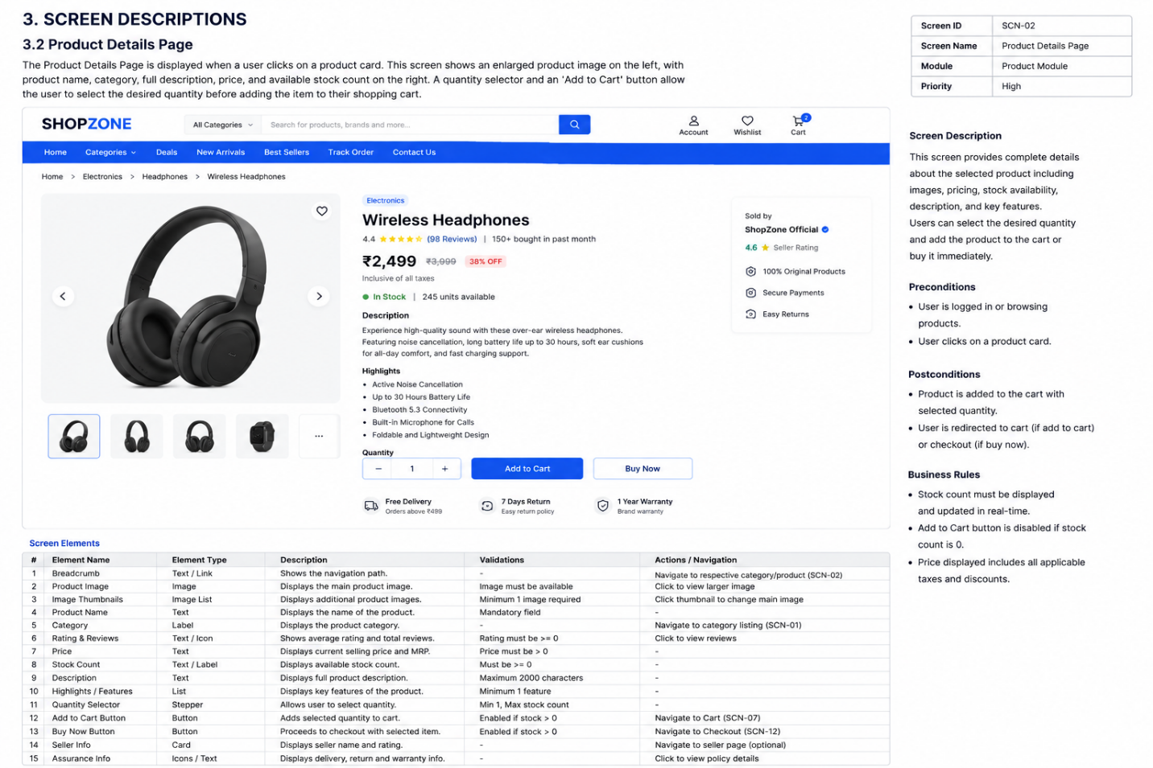

Screen 3: Cart / Checkout Page
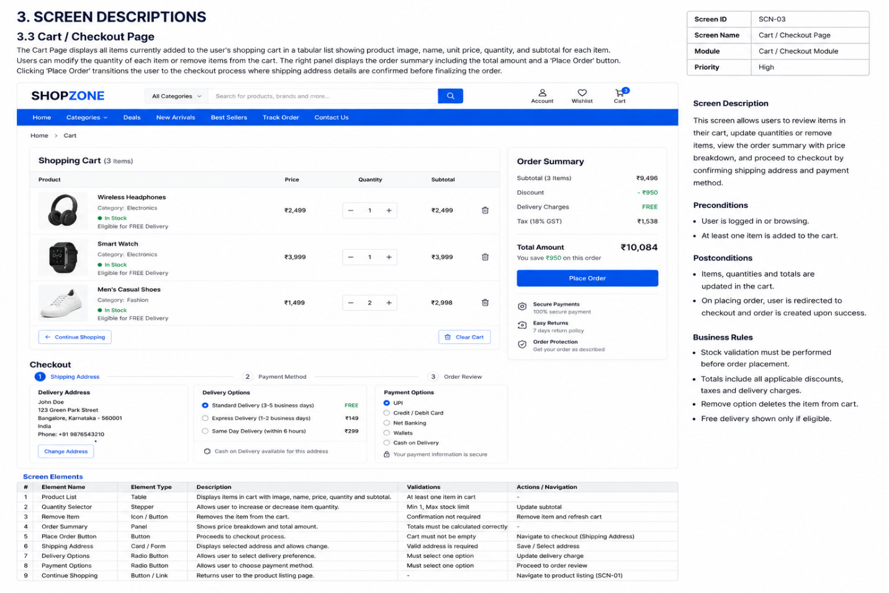

Screen 4: Chatbot Interface Page
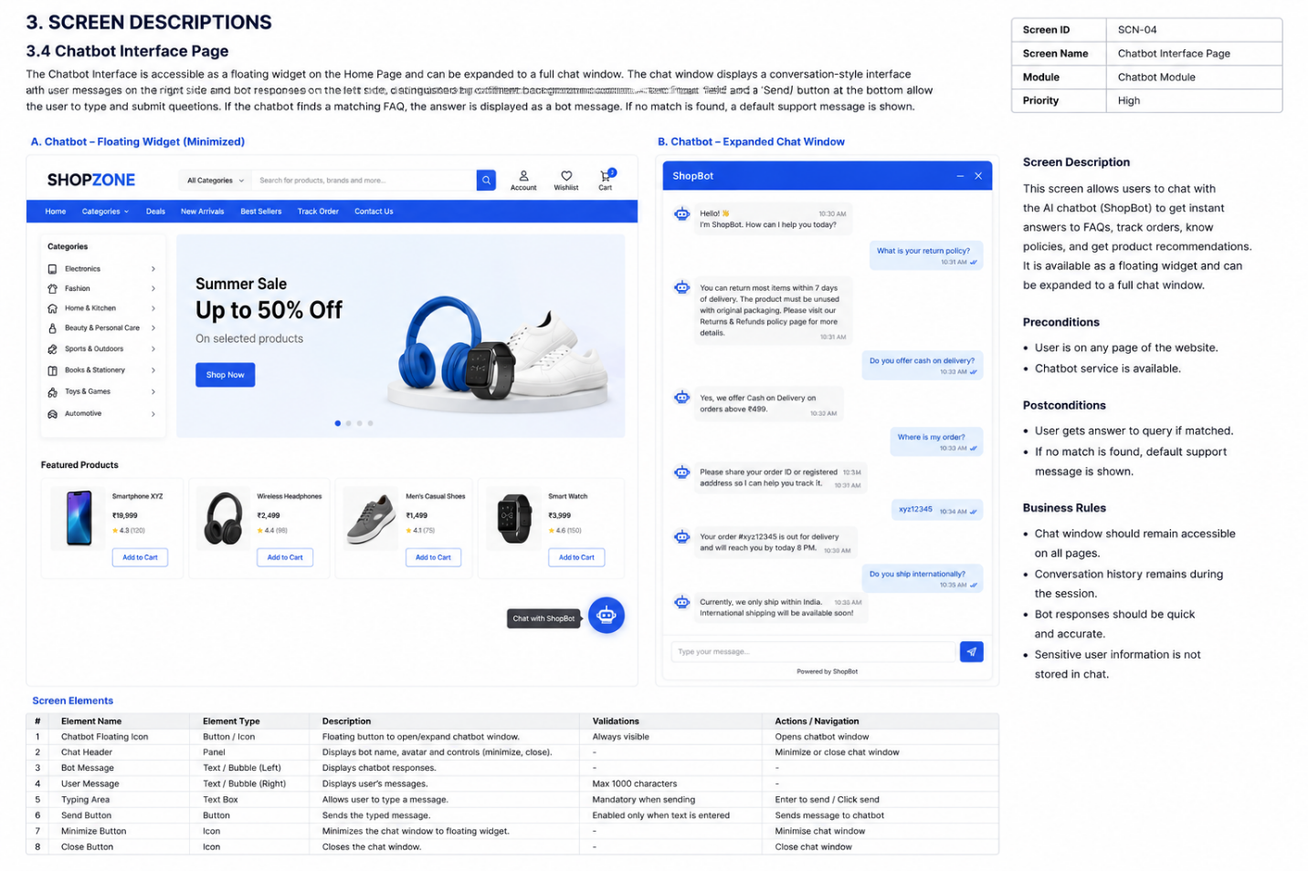

6.3 Screen Objects and Actions
The following table describes the key screen objects present in each major interface and the actions associated with them.

Screen | UI Object / Element | Action / Description
Home Page | Product Card | Clicking opens the Product Details page for the selected product.
Home Page | Add to Cart Button | Adds the product to the user cart and updates the cart badge count.
Home Page | Search Bar | Filters displayed products by keyword match against product name.
Home Page | Category Filter Dropdown | Filters products by selected category.
Home Page | Chatbot Icon | Expands the FAQs Chatbot widget for user interaction.
Product Details | Quantity Selector | Increments or decrements the quantity to be added to cart.
Product Details | Add to Cart Button | Adds the specified quantity of the product to the user cart.
Cart Page | Quantity Input | Allows the user to update the quantity of an item in the cart.
Cart Page | Remove Button | Removes the corresponding item from the shopping cart.
Cart Page | Place Order Button | Initiates the order placement process using cart contents.
Chatbot | Text Input Field | User types their question or query for the chatbot.
Chatbot | Send Button | Submits the user query to the chatbot API and displays the response.
Login Page | Email Input | Accepts user email for authentication.
Login Page | Password Input | Accepts user password (masked) for authentication.
Login Page | Login Button | Submits credentials to the backend API for JWT token generation.
Admin Dashboard | Add Product Form | Admin fills product details and submits to add a new product.
Admin Dashboard | Edit Button | Loads existing product data into the edit form for modification.
Admin Dashboard | Delete Button | Removes the selected product from the database after confirmation.
Admin Dashboard | Order Status Dropdown | Admin selects a new status value and updates the order record.

7. REQUIREMENTS MATRIX
The following traceability matrix maps each functional requirement derived from the Software Requirements Specification (SRS) to the corresponding system component(s) responsible for satisfying that requirement. This ensures complete requirement coverage and assists in verifying that no requirement has been overlooked during design and implementation.

Req. ID | Functional Requirement | System Component | Module
FR-01 | The system shall allow new users to register with name, email, and password. | AuthController, UserModel | User Management Module
FR-02 | The system shall authenticate users via email and password and issue a JWT token. | AuthController, JWT Middleware | User Management Module
FR-03 | The system shall enforce role-based access control (admin vs user). | JWT Middleware, AuthMiddleware | User Management Module
FR-04 | The system shall display a list of all available products on the Home Page. | ProductController, ProductModel | Product Module
FR-05 | The system shall display detailed information for a selected product. | ProductController, ProductModel | Product Module
FR-06 | The system shall allow authenticated users to add products to their cart. | CartController, CartModel, CartItemModel | Cart Module
FR-07 | The system shall allow users to update item quantities in the cart. | CartController, CartItemModel | Cart Module
FR-08 | The system shall allow users to remove items from the cart. | CartController, CartItemModel | Cart Module
FR-09 | The system shall allow authenticated users to place an order from cart contents. | OrderController, OrderModel, OrderItemModel | Order Module
FR-10 | The system shall allow users to view their order history. | OrderController, OrderModel | Order Module
FR-11 | The system shall allow admins to add new products to the catalogue. | AdminProductController, ProductModel | Admin Module
FR-12 | The system shall allow admins to update existing product information. | AdminProductController, ProductModel | Admin Module
FR-13 | The system shall allow admins to delete products from the catalogue. | AdminProductController, ProductModel | Admin Module
FR-14 | The system shall allow admins to view and update order statuses. | AdminOrderController, OrderModel | Admin Module
FR-15 | The system shall provide a chatbot that accepts user text queries. | ChatbotController, ChatbotRoutes | Chatbot Module
FR-16 | The chatbot shall search the FAQs database for a matching answer. | ChatbotController, FAQModel | Chatbot Module
FR-17 | The chatbot shall return a default message when no FAQ match is found. | ChatbotController | Chatbot Module
FR-18 | The system shall store chatbot conversation sessions and messages. | ChatSessionModel, ChatMessageModel | Chatbot Module

8. APPENDICES
This section contains supplementary information that supports the content of this Software Design Description document.

Appendix A: Technology Stack Summary
Layer | Technology | Purpose
Frontend | React.js | Component-based UI library for building the SPA interface.
Backend | Node.js | JavaScript runtime environment for server-side execution.
Backend Framework | Express.js | Web application framework for RESTful API routing.
Database | MongoDB | NoSQL document database for all application data storage.
ODM | Mongoose | MongoDB object document mapper for schema definition and queries.
Authentication | JSON Web Token (JWT) | Stateless token-based authentication mechanism.
Password Hashing | bcrypt.js | Secure password hashing library used during registration.
HTTP Client | Axios | Promise-based HTTP client for API calls from React frontend.
Routing (Client) | React Router DOM | Client-side routing library for SPA navigation.
Architecture | 3-Tier Client-Server | Separation of Presentation, Application, and Data layers.

Appendix B: Development Methodology
The project follows the Agile Software Development Model, which emphasizes iterative development, continuous stakeholder collaboration, and adaptive planning. Development was organized into short sprints, each producing a working increment of the system. The following sprints were conducted:
- Sprint 1: Project setup, environment configuration, User Management Module (Registration, Login, JWT Authentication).
- Sprint 2: Product Module (Product listing, Product details, Admin product CRUD operations).
- Sprint 3: Cart Module (Add to Cart, Update Cart, Remove Item) and Order Module (Place Order, View Orders).
- Sprint 4: FAQs Chatbot Module integration, Chat Session and Message management.
- Sprint 5: Admin Dashboard development, Order management, testing, and bug fixing.
- Sprint 6: UI/UX refinements, responsive design implementation, final testing, and documentation.

